**Scary Teacher 3D**

Ratings: 4.2

Installs: 50,000,000+

Current Version: 5.4.0

Developer: Z & K Games

Game Size: 37M

**Main Menu:**

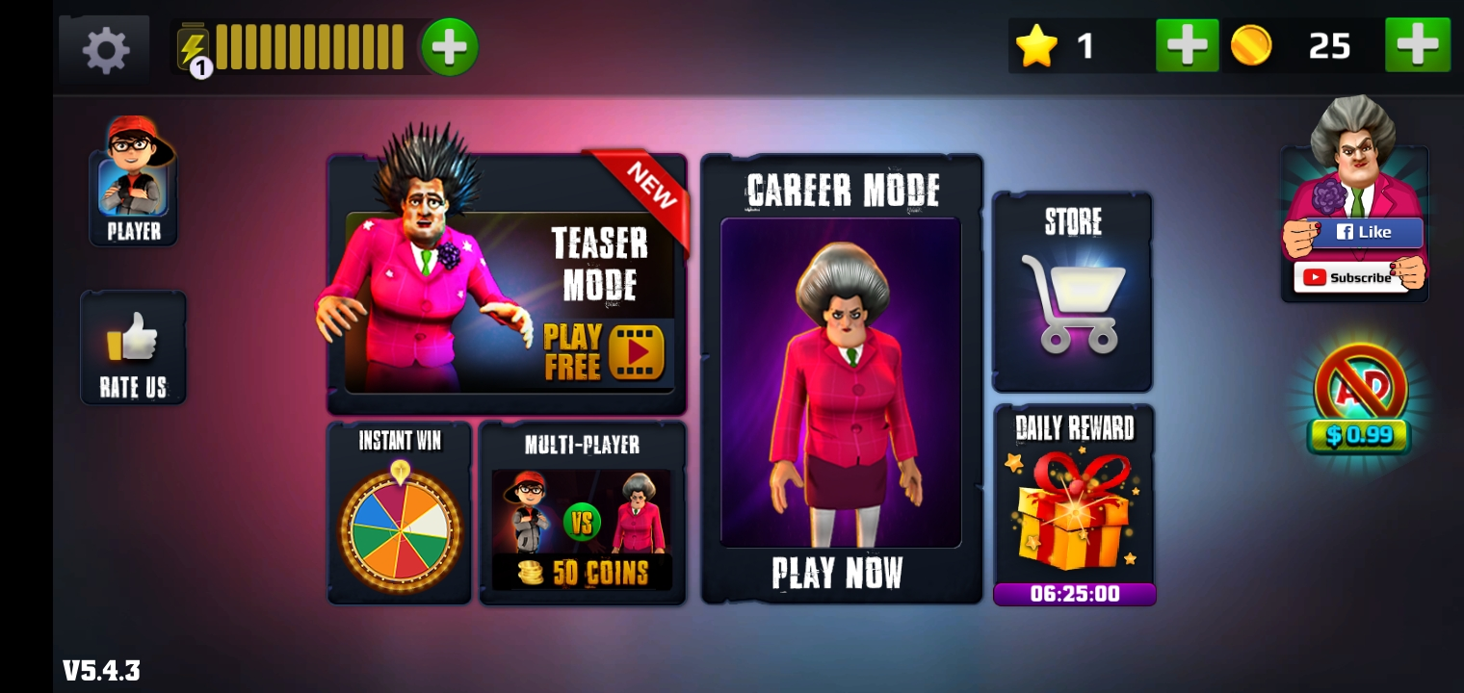

**USER RETENTION:**

The ads are placed in multiple areas of the game. To play the teaser mode, player has to watch an ad to enter this mode. Ad appears when the player presses the home button to go back from a level to Home. After pressing each button, a pop up appears that gives the user a kind of reminder to buy different items such as coins, energy, stars, and no ads version of the game to play smoothly and some pop ups also have attractive offers such as discounts up to 50%. Instant spin has price wheel that allows the user to spin one time for free in a day and win the maximum reward of 200x coins. To spin the wheel again, user has to watch an ad. The store is free and the items in the store can be bought with the coins earned by completing levels or by using instant spin. Daily Reward is used to reward player different items. On reward is free to claim each day. To unlock more daily rewards, player has to watch an ad. The player is given option on the menu to remove ads for 0.99$. The game has kept an option to attract both male and female players by giving option to choose from a male or female avatar. To earn free 50 coins, player has to watch an ad. For more coins, player has to pay form 0.99$ to 9.99$ depending upon the amount of coins. After completion of each level, an ad appears and the player is rewarded 50 coins and a star if the player finds and collects it in the game. First chapter is free to play and to unlock Chapter 2, 3, and 4, player has to pay 0.99$ to continue chapters. To play the multiplayer mode, player has to watch and ad if there are no sufficient coins.

**Pop Ups:**

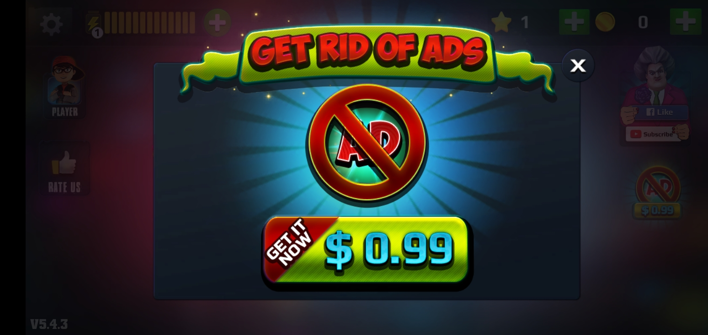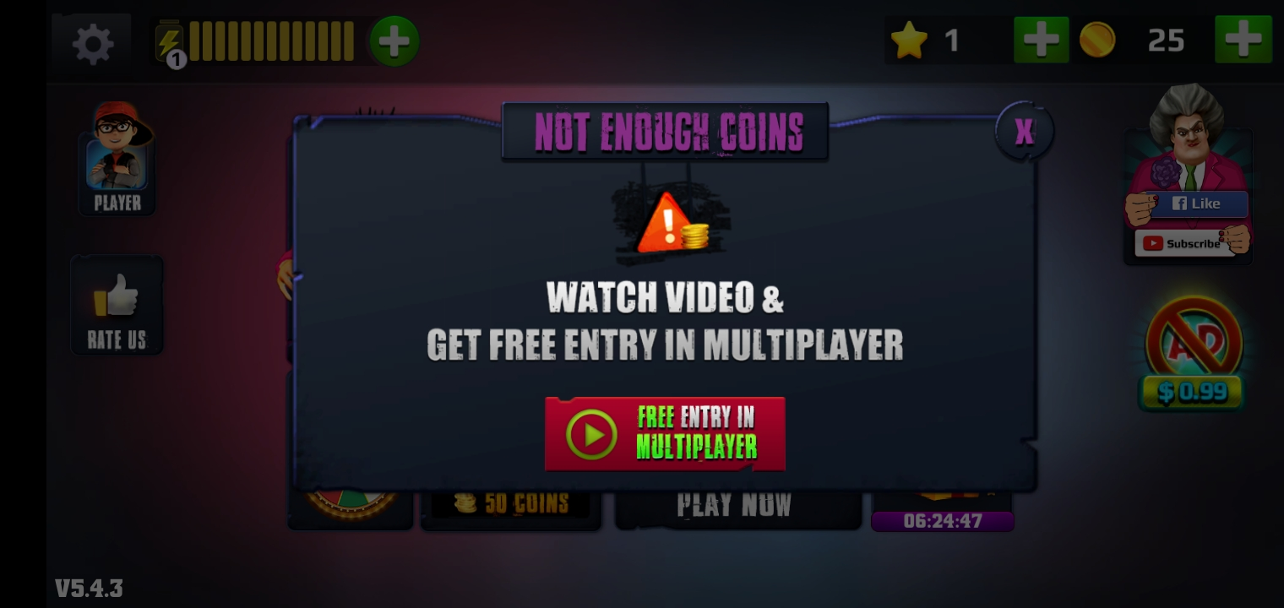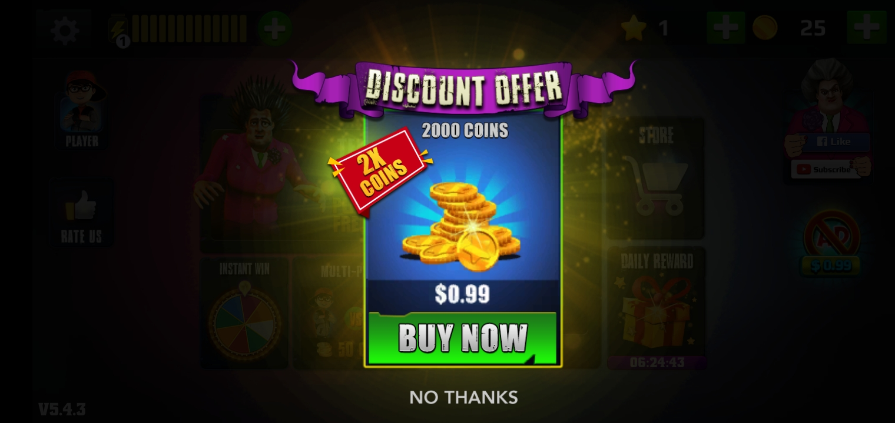

**FEEL AND SATISFACTION:**

The satisfaction level of this game is low to medium as there are multiple glitches in the game. The connectivity of objects with the character is not kept smooth. The theme of horror and escape is followed completely in this game. The thrill of escaping and saving the player from being caught is well preserved. The graphics are of medium quality that makes the game playable if the users are not demanding high graphics. Player has given choice to play with either Nick as male avatar and Tani as female avatar which gives the user liberty to choose an avatar of his/her choice. There are too many buttons showing while playing that sometimes is confusing when the player has to run, jump, and turn simultaneously. Player is unable to turn right or left in the start of each level. The turning ability comes gradually after some time. The game shows directions to complete tasks initially but does not guide the player during the game and the objects are always mixed up with the background.

Character and object connectivity:

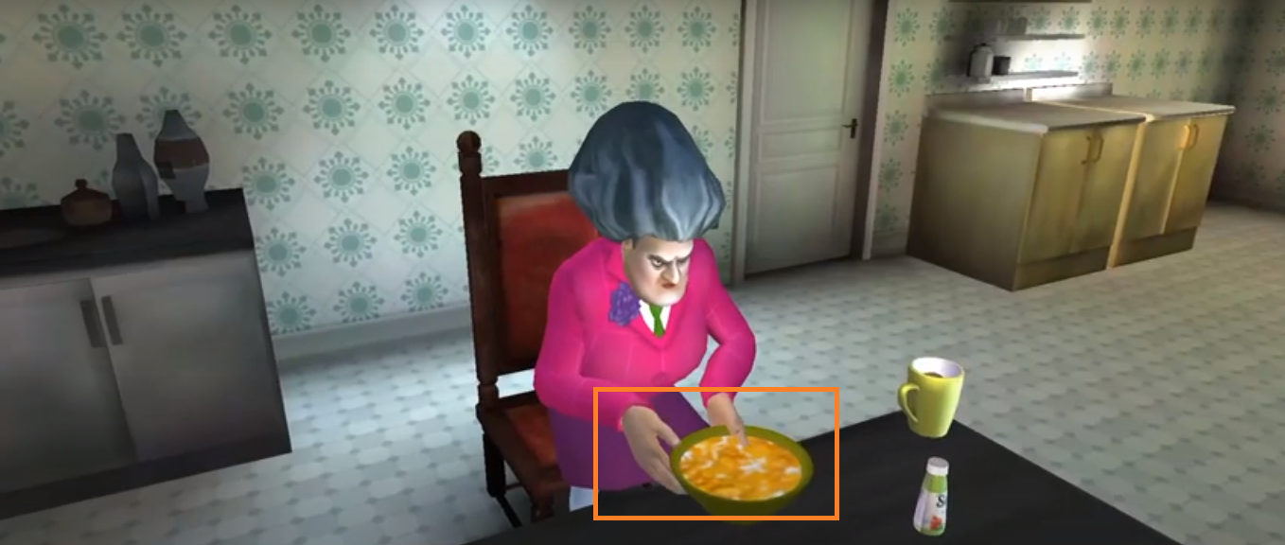

**GAME DURATION:**

--Teaser Mode:

Player can use different objects such as paper ball, eggs, cake, and other objects to throw at the teacher while teacher stays static on the screen and react differently to each object thrown.

This concept is taken from

--Career Mode:

4 Chapters with 2 Special Chapters

Each chapter has 14 levels

--Multiplayer:

Player has to give 50 coins to play this level but the only two players are thief and the scary teacher. Player cannot play with other players online.

The game has 1 hour of gameplay.

**MARKETING:**

Facebook: <https://www.facebook.com/Scary-Teacher-104953160859907/>

YouTube: <https://www.youtube.com/channel/UC6z4RnDkI5DALyx3M1qEmPQ>

YouTube influencers:

games hole: 1.03M Subs

Kindly Keyin: 2.81M Subs

I am Khaleel: 629K Subs

Gaming Point: 123K Subs

BuciGames: 150K Subs

OBJECTIVE:

The objective of this game is to teach Miss T, the scary teacher, not to mess with the kids. Escape from her home by successfully completing each task in different levels. Don’t get

REFERENCE GAMES:

-My Talking Tom:

iOS: <https://apps.apple.com/us/app/my-talking-tom/id657500465>

Android: <https://play.google.com/store/apps/details?id=com.outfit7.mytalkingtomfree&hl=en>

# -Evil Nun: Scary Horror Game Adventure

iOS: <https://apps.apple.com/us/app/evil-nun-the-horror-s-creed/id1410194646>

Android: <https://play.google.com/store/apps/details?id=com.keplerians.evilnun>

# -Granny: Chapter Two

# iOS: <https://apps.apple.com/us/app/granny-chapter-two/id1479175321>

# Android: <https://play.google.com/store/apps/details?id=com.dvloper.grannychaptertwo>

-Hello Neighbor

iOS: <https://apps.apple.com/us/app/hello-neighbor/id1386358600>

Android: <https://play.google.com/store/apps/details?id=com.tinybuildgames.helloneighbor>